
LIGHTFOOT LODGE DAY SERVICES PROVIDED BY VIVO CARE CHOICES

Lightfoot Lodge- Lightfoot Street, Chester, CH2 3AD
Tel-07731983817

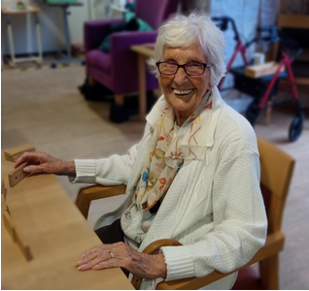

Opening times-
Monday to Friday 9.00am – 5pm

Lightfoot Lodge is a day service for adults living with dementia.

The services are for individuals mainly over the age of 65 who live in Chester, Ellesmere Port and the surrounding areas.

We provide a high quality, caring, responsive and stimulating day service. We will work with you to meet your needs, maximising your choice, independence and wellbeing.

Day Services offer the opportunity to socialise in a safe and supportive environment, and also provides respite for carers.
Prior to the commencement of your service we will discuss and agree your care needs. Following this we
will create a Personal Support Plan which we will share with you.
Engaging and meaningful activities enable the development of confidence, and a positive self image.
The varied activity programme encourages socialisation, communication, and physical and mental stimulation, whilst providing an opportunity to meet other people, share skills, experiences, memories and enjoyment.

We offer a range of activities to meet individual’s own interests and needs, examples include-
- Exercise groups
- Bingo sessions
- Reminiscence
- Quizzes/ word games
- Dominoes/cards
- Music & Sing-a-long
- Baking
- Arts & crafts group
- Knit ‘n’ natter
- Coffee mornings/afternoon tea
- Pamper sessions
- Carpet bowls
- Flower arranging
- Discussion groups

Meals:
A hot meal and sweet is available during your day at a cost of £9.07
Unlimited refreshments are also available throughout the day.
Prices correct as of 1st April 2026

Transport:
Transport to day care is available through request from social services. See contact information below.

Experienced staff:
All our staff are DBS checked, receive regular appropriate training and have the knowledge, skills and experience to deliver a consistent, high quality service. All Support Workers employed by the company are required to follow policies and procedures which are designed to ensure the highest quality of service to clients and to protect confidential information.

How to access the service:
The service is open to anyone with a care act assessment. If you are not currently open to a social worker, please contact Cheshire West Community Access Team: Telephone: 0300 123 7034

Further information can be found on our website-
www.vivocarechoices.co.uk

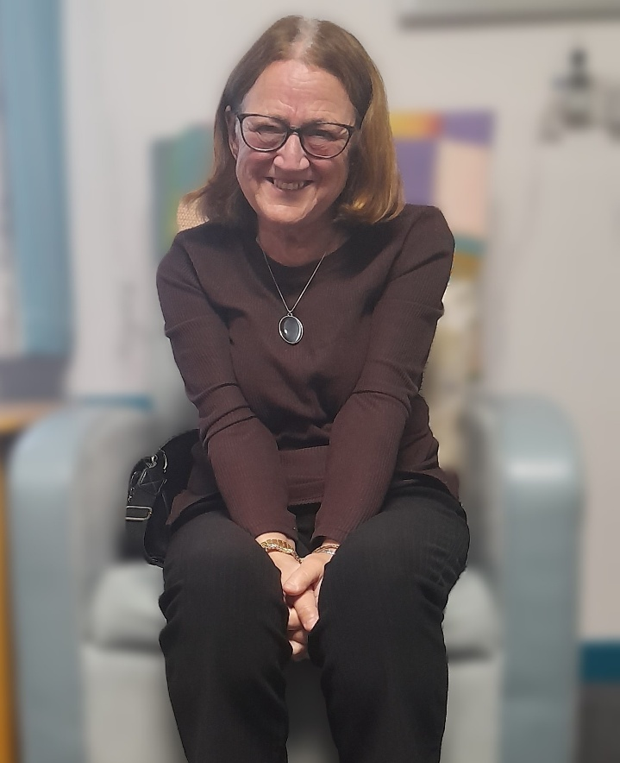

For more information please contact Laura Penk- 07731983817
Laura.penk@vivocarechoices.co.uk

Or Sarah Powell 07970497590
Sarah.powell@vivocarechoices.co.uk

Costs for Older People’s Day Care

When completing your care act assessment, your social worker will also complete a financial assessment, and will be able to advise you on your assessed charge.

Vivo Care Choices Services are provided respecting the differences between people taking account of needs relating to race, gender, disability, age, faith or sexual orientation.

