
Directory of local services

Mental Health
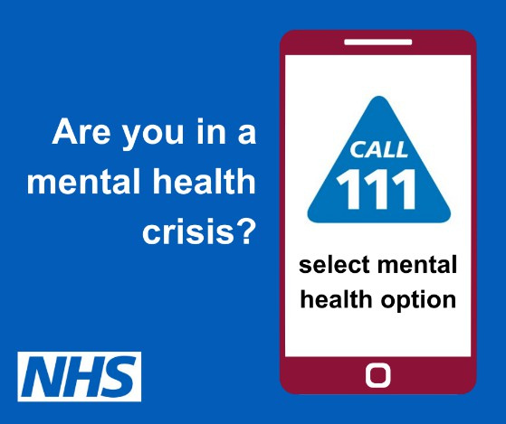
www.cwp.nhs.uk/contact/need-urgent-help
All age 24/7
Call NHS 111 Select Mental Health Option 2


Crisis Support – 18+
01244 393139 10am until 10pm 365 days a year
71-77 St.Anne Street, Chester, CH1 3HT www.spiderproject.org.uk/cafe71 enquiries.chester@spiderproject.org.uk


A free and confidential service available to anyone aged 16 and over
The service exclusively offers evidence-based, short-term talking therapies designed to help with common mental health concerns, such as:
- Low Mood, Anxiety or worry, Stress, Depression 0151 488 8348 Mon-Fri 9am until 5pm www.talkingtherapies.cwp.nhs.uk/self-refer

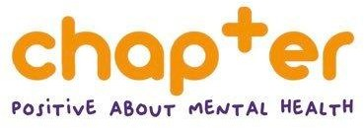
01244 344409 18+
Mon-Fri 9am until 5pm
www.chaptermentalhealth.org/services



0-16 years
www.mymind.org.uk/coping/self-help-resources
Supporting Children & young people aged 8-25 with mild to moderate mental ill health, with 1-2-1 support and group sessions.
Email: YourMindMatters@YouthFed.org to request a referral form or call: 0151 357 1971


Men, is it time to talk?
Mentell provides men’s groups online and face to face, for males aged 18+ to talk in a safe and confidential space, free form advice and judgement.
www.mentell.org.uk/signup
Local Group: Hoole Community Centre, CH2 3AP


Going through a storm or just been through one?
Andys Man Club are free talking groups for men to help you through those storms.
Every Monday @ 7pm ex bank holidays
The Army Welfare Service (The Hughes Centre), Crookenden Road, The Dale, Chester, CH2 4AY
info@andysmanclub.co.uk https://andysmanclub.co.uk


Free Adult ADHD self support- 8 week course Whitby Hall, Ellesmere Port, CH65 2ER Wednesdays 6-8pm
Contact nddirected@gmail.com or call 07507 653066 https://nddirected.org
Booking Required

A welcoming space for autistic people to visit and access services, through one to one consultations, regular ‘pop in and chat’ sessions and training courses.
Based at Dial House, Hamilton Place, Chester, CH1 2BH 01244 345655
www.westchestcheshireautismhub.org.uk

Drug & Alcohol services


Via– New Beginnings, Aqua House, CH3 5AF 0300 303 4549
See website for opening hours www.viaorg.uk cwac@viaorg.uk Over 18’s cwacyp@viaorg.uk Under 18’s

Families
Local Centre – Blacon
Carlisle Road, Blacon, Chester, CH1 5DB
01244 397412 Monday -Friday 9am until 5pm
www.startingwell.org.uk
0-19 years
Parents & Carers ‘Ask us anything’ Text 07312 263156
11-19 yr old’s support
Text 07312 263260



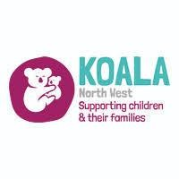
Supporting Parents and Families with Children aged 0-19 years, (upto 25yrs with SEND) with a wide range of services
Website: www.koalanw.co.uk Email: admin@koalanw.co.uk Telephone: 0151 294 5885


www.catchapp.co.uk
CATCH is a free NHS health app for parents and carers of children from pregnancy to age 5
www.thedadpad.co.uk
The DadPad app is available for all new dad’s and dad’s to be within the Cheshire and Merseyside area.

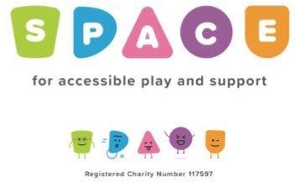

Support for Children with additional needs and their families. (Family play sessions, parent/carer support, training for parents/carers, counselling)
www.spacecheshire.org 01244 377646
admin@spacecheshire.org
A safe welcoming space for all. Supporting mental and emotional health.
Family connect & play sessions (£2 per Family), free art & wellbeing classes, Men’s mental health support groups, free wellbeing sessions
Coffee & Chat sessions-Bereavement support for families who have experienced pregnancy & babyloss
Phone: 01244 575287 email : contact@calmcic.com

Cheshire West


www.livewell.cheshirewestandchester.gov.uk
Information about local services and support for residents in Cheshire West


‘Let’s Talk’ drop in sessions
www.cheshirewestandchester.gov.uk/residents/health-and-social-care/adult-social-care/lets-talk-health-and-wellbeing/
Advice for residents living in Cheshire West including:
- Access to community activities, advice on managing activities relating to daily living, advice about equipment, aids and adaptations, cost of living advice and support, advice on how to access support and activities to reduce social isolation and loneliness. Carer support, consumer advice.


Adult Social Care
Community Access Team 0300 123 7034 Mon-Fri 9am until 5pm
Emergency Duty Team 01244 977277
Mon-Fri 5pm until 8.30am. 24 hrs weekends & b.hols emergencydutyteam@cheshirewestandchester.gov.uk
Self Assessment can also be completed via the website 18+ only
https://adultsocialcareonline.cheshirewestandchester.gov.uk


Support to remain in work of find work for over 18’s with
a physical or mental health disability. Does not have to be on benefits.
If you would like to be referred for Employment Directions, talk to your GP or other healthcare provider or self-refer through the email address below:
IPS@cheshirewestandchester.gov.uk

Individual Placement & Support
An NHS provision that supports people with severe mental health difficulties to find and sustain meaningful paid work.
Call: 0161 881 4826, option 5 email: referrals@standguide.co.uk
www.standguide.co.uk/index.php/nhs-ips

Carers



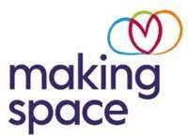
Helpline 0300 102 0008 Mon-Fri 9am until 5pm Saturday 9am-12.30pm www.bettertogetherwestcheshire.org
18+
Cheshire Young Carers 6-18 years 0151 356 3176
www.cheshireyoungcarers.org
Support for Carers looking after someone with Learning difficulties of any age, or Mental health issues over the age of 18
Tel: 01606 606694
enquiries@makingspace.co.uk

Older people’s services



Support for 55+ General advice & info, IT advice, falls prevention, scams awareness, home hazard assessment and advice
01244 401500
admin@ageukcheshire.org.uk
Buddy & Befriending Service
Support for 50+ living in Cheshire West who are lonely or socially isolated.
07919 327131
befriending@changing-lives-together.org.uk
Supporting older people live independently - Aged 65+ Must live in own home, socially isolated and/or lonely 0300 666 0004
info@snowangels.org.uk
www.snowangels.org.uk/referrals/ to complete self referral form

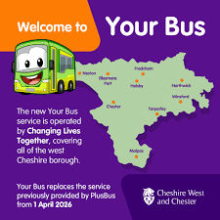
Your Bus is a low cost, bookable community transport service for residents in the borough of Cheshire West & Chester - Running Monday to Friday
See the website below for eligibility details - (there is a charge to use this service)
www.yourbus.info Call: 01606 784100


The Memory Café is a place for people with dementia, their families, friends and carers to come together and enjoy a cuppa in the unique setting of the zoo. Bembe Coffee Shop is at the main entrance, which is free to access and has plenty of FREE parking too
Our Memory Café takes place on the second and fourth Monday of each month from 10.30am-12pm.
Our Memory Café is free to attend and there is no need to book

General health

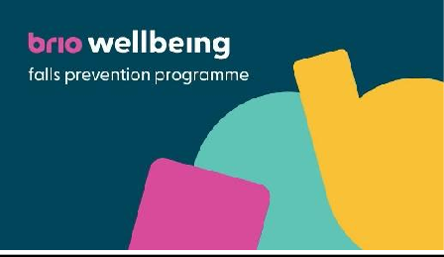
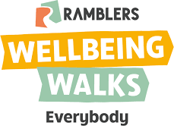

Call 0300 777 0033 for advice 18+
Quit smoking, weight management, falls prevention
Apart from quit smoking support all will need a GP referral and are subject to certain criteria.
wellbeing@brioleisure.org
Weekly walks across Cheshire West and Chester led by trained walk leaders and coordinated by the Health Ranger team at Cheshire West and Chester Council.
www.ramblers.org.uk/go-walking/
We have a vision to support and empower women from all backgrounds, facing any personal issues, to live equal and fulfilled lives. If you need support and want to make positive changes in your life, Tomorrow’s Women can help! We offer free courses, activities and support in an all women’s safe space women 18+
Tomorrow’s Women Chester
5 Upper Northgate St, Chester, CH1 4EE 01244 906494
www.tomorrowswomen.org.uk

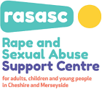
Support Centre (Cheshire and Merseyside) that aims to provide crucial specialist support, independent advocacy, counselling, help and information, for those affected by rape, sexual assault and/or abuse – a free of charge
service delivered in a safe and non-threatening environment. Information line: 0330 363 0063
Email: support@rapecentre.org.uk
Website: www.rapecentre.org.uk

If you, or someone you know is in a relationship that doesn't quite feel right, speak to someone about it. You can get help and advice and access self-support services from the Open the Door website www.openthedoorcheshire.org.uk
or call 0300 123 7047, option 2.



Supporting people with neurological conditions through access to regular exercise, professional help, info & support and social activities. (There may be a charge for some services)
01244 678619
www.neurotherapycentre.org
Macmillan Support and Information Centre Countess of Chester Hospital
Usual hours Mon-Fri 9.30am-4.30pm Koren Bailey 01244 364948 cancer.support@nhs.net


Supporting people who are deaf or deafblind with a wide range of support and services in Cheshire
0333 220 5050
www.dsnonline.co.uk dsn@dsnonline.co.uk


Sight Loss Information Line 01244 478910
Email: referrals@visionsupport.org.uk
9am to 5pm Mon to Thursday, 9am to 4.30pm Friday

